- Penxoniks Sdn. Bhd. has recently launched its new products. In view of the sales that have been very encouraging since then, Mr. Alex Tham, the Sales Director of Penxoniks, has decided to computerize the sales and inventory system.

The software organization that you work with has successfully bid for the above mentioned project. You, as one of the project managers in your software organization, have been appointed to lead this project. During the initial requirement study exercise, your team noticed that the staff members of the Sales Department of Penxoniks are all very supportive of this upcoming project. They are able to explain their requirements very clearly in the recent interview sessions. Furthermore, most of them have highlighted to you that they hope the new system should have a very low learning time.

The top management of Penxoniks wants the new system, which will include an online order and payment feature, to be available before Christmas. They believe that this online feature will boost their sales during the Christmas and New Year festive season. Hence, the project team will only have about three months to work on this project. Top management has also emphasized that the new system’s downtime should not be more than 0.05%. Furthermore, the new system should be developed using the Object-Oriented Analysis and Design Development Methodology and must be implemented based on the Oracle database.

- Compose the user and system requirements for the Online Order and Payment function mentioned in the scenario.
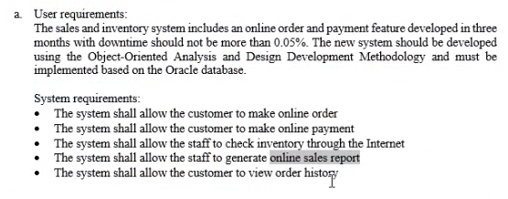

- Non-Functional requirements can be categorized into three main categories, namely product, organisational and external.

Identify 4 non-functional requirements requested by the management and staff of Penxoniks in the above scenario. For each identified non-functional requirement, indicate whether it is a product, organisational or external requirement.
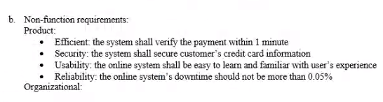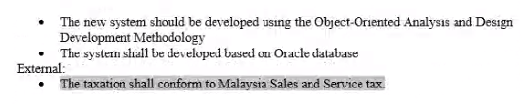

- System requirements specification (SRS) is the main output document of Requirements Specification stage and it is usually presented in a structured form of natural language supplemented by system models and tables.

- Analyse the possible problems of writing this document in natural language.
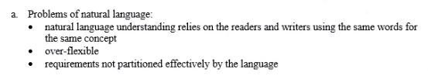
- Suggest and explain 2 alternatives to using natural languages.
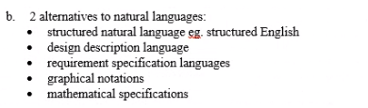

- This is one of the user requirements provided in the requirement documentation:

This e-shopping system shall allow online users to search, select and purchase their desired product online.

Prepare the 3 functional requirements and 3 non-functional requirements from the above user requirement.
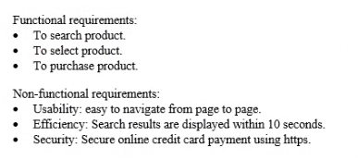

- EPS Company is currently researching into Track Your Truck (TYT) application that offers an efficient and effective vehicle tracking system. TYT allows users to check real time location of their vehicles through Global Positioning System (GPS). Users can also view their vehicles’ fuel usage, mileage, performance analysis reports through TYT. In the event of vehicle theft, a notification message will be sent to police station automatically and to the owner at the same time. In order to recover the lost vehicle the real time location can be tracked by the owner. (Source :http://www.trackyourtruck.com/)

- Give 4 functional requirements for the Track Your Truck system.
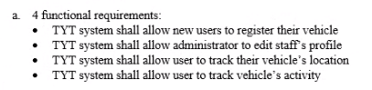
- Explain 2 problems if you are to construct user requirements using natural language.
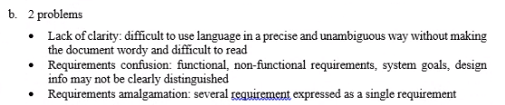

- Sri Touch Academy is a newly established company in Kuala Lumpur which offers make-up, hairstyling, and art courses. The courses are conducted in both full time and part time modes. As a software engineer, you are responsible to build an online website for the company to allow customer to register as member, pay the fees, check classes’ schedule, post questions, share success story, subscribe to weekly newsletter, chat with company personnel, and connect to other social networks such as Facebook Page, Twitter, and Instagram. You have three months to accomplish the project together with your junior software engineer. Sri Touch Academy requested you to deliver the initial version within two months and the subsequent within one month.

Produce 2 functional requirements and 2 non-functional requirements for the online website based on the case study.
